RESOLUTION NO.__________

RE: CERTIFICATE OF APPROPRIATENESS UNDER THE
PROVISIONS OF THE ACT OF THE PENNSYLVANIA
LEGISLATURE 1961, JUNE 13, P.L. 282 (53
SECTION 8004) AND BETHLEHEM ORDINANCE NO.
3952 AS AMENDED.

The applicant proposes to install signage in two locations at 531 Main St.

NOW, THEREFORE, BE IT RESOLVED by the Council of the City of Bethlehem that a Certificate of Appropriateness is hereby granted for the proposal.

Sponsored by: (s)

(s)

ADOPTED BY COUNCIL THIS DAY OF

(s)
President of Council

ATTEST:

(s)
City Clerk

HISTORICAL & ARCHITECTURAL REVIEW BOARD

The applicant proposes to install signage in two locations at 531
Main St.

APPLICATION #5:

Buxmont Academy
531 Main St.
Bethlehem, PA 18018

OWNER:

__________________________________________________________________________

The Board upon motion by Marsha Fritz and seconded by Diana Hodgson adopted the proposal that City Council issue a Certificate of Appropriateness for the following:

- Two new signs to be installed, one on the building and the other a hanging blade
sign.

2. The center sign is not to engage the center stripe, (approx. 2-3” short of that stripe).

3. The corners of both sign are to be squared inwards instead of scalloped.

4. The motion was unanimously approved.

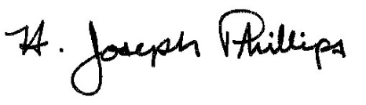 By:__H. Joseph Phillips___________

Title: __Historic Officer____________

Date of Meeting: November 7, 2018

